A project report

On

<< Mero Virtual Saathi>>

Submitted in partial fulfillment of the requirement of Project– II (BIT 156 CO)

Of

Bachelor of Information Technology

**Submited to**



Purbanchal University

Biratnagar, Nepal

**Submitted By**

<John Subba> <University Symbol >

<Rishi Khadka> <324526 >

**KANTIPUR CITY COLLEGE**

Putalisadak, Kathmandu

August 10, 2022

A project report

On

<< Mero Virtual Saathi >>

Submitted in partial fulfillment of the requirement of Project– II (BIT 156 CO)

Of

Bachelor of Information Technology

**Submited to**

Purbanchal University

Biratnagar, Nepal

**Submitted By**

<John Subba> <University Symbol >

<Rishi Khadka> <324526>

**Project Supervisor**

**<<Saroj Pandey >>**

**<<Designation>>**

**KANTIPUR CITY COLLEGE**

Putalisadak, Kathmandu

August 10, 2022

**Certificate of Project Approval**

It is here by informed that the topic selected by John Subba, Rishi Khadka of BIT Second semester project has been found suitable and as per the credit assigned by Purbanchal University (PU), Biratnagar, Nepal. The Project Committee has approved the following topic and supervisor for the mentioned students. This project has been completed for the prescribed period and the project embodied the result of their investigation conducted during they worked as full-time student of this institution.

Topic Approved: Mero virtual Saathi

_____________________ __________________

Mr. Saroj Pandey Mr.Saroj Pandey

Deputy HOD, Department of Information Technology Project Supervisor

Kantipur City College Kantipur City College

**Certificate from Supervisor**

This is to certify that the project titled “Mero Virtual Saathi” submitted by John Subba, Rishi Khadka to the Department of Information Technology, College of Science and Technology at Kantipur City College, Kathmandu, Nepal towards the requirement for Project- II (BIT156 CO) of is an original work carried out by them under my supervision and guidance.

____________________

Saroj Pandey

Department of Computer Engineering

Kantipur City College

(Project Supervisor)

**Acknowledgment**

We would like to use this opportunity to thank all who lend their hand for completing our project successfully. First of all I would like to thank almighty. Who drove us through our project with his blessing and providing us with enough support to make it a success?

We are grateful to our project supervisor 'Mr. Saroj Pandey' who was there to guide us along the project, providing us assistance in doing the things in a proper and appropriate manner. Without him supervision this project would have been a tedious task for us.

We would also like to express our sincere thanks to Mr. Raju Katel (principal of KCC) for giving us this opportunity to undertake this project. We also like to thank our lecturer Mr. Nishan Lamichhane sir and all the KCC management, team for whole hearted support.

We would like to extend our gratitude to my Friends and management for providing us with good services and creating an environment for carrying our project. Last but not least, we would like to express our sincere thanks to all our friends and other who helped us directly or indirectly during this project.

**Abstract**

With the advancement of technology AI (Artificial intelligence) have become more and advanced and use in every aspect or every electronic devices which work automatically or manually. The massive use of virtual assistant we have designed a simple and easy to work with in the devices a virtual assistant ‘Mero Virtual Saathi’.

This project report on “**Mero Virtual Saathi**” consists of background and significance of the project with objectives, features and problem-solving statement of the project which shows the detail information about the research done about existing system and limitation of them and its working mechanism with proper functionality. And we are hopeful that this project (Mero Virtual Saathi) might be helpful for most of the users who desire to communicate with the AI and do some Operating System OS task which are instructed by the user.

**LIST OF FIGURES**

**Figure no.1 Figure caption Page no**

1 Gantt chart

2 Appendices

**LIST OF TABLES**

**Table no. Table caption Page no**

1. Assignment of role and responsibilities
2. Requirement gathering
3. Function analysis
4. Test plan

Table of Contents

Chapter 1: Introduction 10

1.1 Background 10

1.2 Problem Statement 10

1.3 Objective 10

1.4 Features 10

1.5 Assignment of role and responsibilities 11

Chapter 2: System Analysis 11

2.1 Requirement gathering 11

2.2 Gantt chart 12

3.1 Function Analysis 12

3.2 Algorithm 14

Chapter 4: System Development and Implementation 18

4.1 Programming platform 18

4.2 Test plan 18

4.3 Implementation and result analysis 18

Chapter 5: Conclusion 18

5.1 Conclusion 18

5.2 Limitations 18

Reference 18

Appendices 19

# 

# Chapter 1: Introduction

## Background

“Virtual Assistant” which is also known as “Intelligent personal assistant” (IPA) is a software agent that can perform tasks or services for an individual based on commands or question. As in 1990’s digital speech recognition technology became a feature of the personal computer with IBM, Philips and Lernout and Hauspie fighting for customers. As much later the market launch of the first smartphone IBM Simon in 1994 laid the foundation for smart virtual assistants as we know them today.

The term “chat bot” is mostly used to represent the virtual assistants. In some cases, online chat programs are exclusively for entertainment purpose some virtual assistants are able to interpret human speech and respond via synthesized voices. As users can ask their assistants questions, control home automation devices and media playback via voice or by typing and manage other operating systems.

## Problem Statement

## Objective

* To create a virtual assistant application to chat with it and command it to do basic OS related jobs.

## Features

* Saathi gives response by audio and displaying in it’s dialogue box.
* Can determine nature of user input sentence.
* Can answer static GK- questions.
* Can even answer certain user communicated history details.
* Can perform basic operating system tasks.

## Assignment of role and responsibilities

|  |  |
| --- | --- |
| **Team Members** | **Role and responsibilities** |
| John Subba | Documentation, coding, Logic development, designing, debugging |
| Rishi Khadka | Documentation and coding, designing, debugging & research |

# Chapter 2: System Analysis

## 2.1 Requirement gathering

## 

## 2.2 Gantt chart

|  |  |  |  |  |  |  |  |  |
| --- | --- | --- | --- | --- | --- | --- | --- | --- |
| Task | March | April | May | | June | | July | August |
| Concept gathering |  |  |  |  | |  | |  |
| Requirement gathering |  |  |  | |  | |  |  |
| Analysis and system design |  |  |  | |  | |  |  |
| Coding and development |  |  |  | |  | |  |  |
| Testing and debugging |  |  |  | |  | |  |  |
| Maintenance |  |  |  | |  | |  |  |
| Documentation |  |  |  | |  | |  |  |

# : - All members total effort

Chapter 3: System Design

## 3.1 Function Analysis

This system contains distinct functions, header files that helps in running our project. All the header files and functions used in our project are given below along with their characteristics and descriptions:

3.1.1 Header Files

|  |  |
| --- | --- |
| **Header file** | **Description** |
| #include<iostream.h> | All standard library functions for file input and output are included on iostream.h |
| #include<conio.h> | All console input/output functions are included in conio.h |
| #include<cstdlib> |  |
| #include<array> |  |
| #include<fstream> | fstream.h helps to handle different file operations |
| #include<unistd.h> | For delay sleep |
| #include<string.h> | Calculate the length of string, copies a string into another |
| #include<windows.h> | To access the win 32 API function |
| #include<algorithm> |  |
| #include<time.h> |  |

3.1.1 Classes & Structure

|  |
| --- |
| **Class** |
| Bounder_frame |
|  |
|  |

|  |
| --- |
| **structure** |
| Number_mark |
| User_speech_copy |
| Greeting |
| Question |
| Task |
| statement |

## 3.2 Algorithm

**Main Fun ()**

Step1: Start

Step 2: Display main screen

Step3: Create a user class object and call its user input member function.

Step4: Run the input function in an infinite loop until exit command is given by the user.

Step5: Stop

**User input fun ()**

Step1: Start

Step2: Take user input strings.

Step3: Analyze the string and provide value to it:

* String is a greeting; assign value.
* String is a command; assign value.
* String is a Question; assign value.
* String is a Statement; assign value.

Step4: Call respective fun () as per the activated value.

Step5: Stop

**Greeting fun ()**

Step1: Checks for certain specific salutations. If true same response in return.

Step2: If normal salutations is deduced- open greeting response file and call random greeting.

Step3: Save the user greeting string in the same file for future reference.

Step4: Exit.

**Command fun ()**

Step1: Check for certain specific meaning words.

Step2: If matched begin sub-checking of rest words-for tasks value.

Step3: Perform the given task. If task value not determined then open browser by default.

Step4: Stop

**Question fun ()**

Step1: heck for certain specific w/h question.

Step2: If matched begin then, it open the question respond file and call the answer that you’r asking.

Step3: Save the question for future reference.

Step4: stop

**Statement fun ()**

3.3 Flowchart

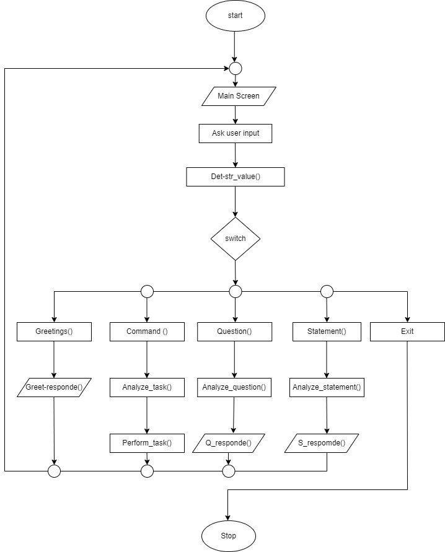

# Chapter 4: System Development and Implementation

## Programming platform

Computer software specification we have used for development:

* Operating System: Windows 10 Operating System
* IDE: Dev C++ 5.11 / Code Blocks
* Programming Language: C++

## 4.2 Test plan

## 4.3 Implementation and result analysis

# Chapter 5: Conclusion

## 5.1 Conclusion

Mero Virtual Saathi is a starting step to create a more capable virtual assistant

## 5.2 Limitations

# Reference

* Balagurusamy, E.(2011). Object Oriented Programming With C++. New Delhi, Tata McGraw Hill Education Private Limited.
* C++ reference.(April 30,2022). Iterators library. <https://en.cppreference.com/w/>

* eSpeak text to speech. (June 10, 2022). Command line options. https://espeak.sourceforge.net/commands.html
* Kartikey Sankhdher. (July 8,2022). My J.A.R.V.I.S. Program Quick Demo. https://youtu.be/OCxL-V2Zt8A

# Appendices